American International University-Bangladesh (AIUB)

Introduction to Database

Project: Airport Management System

#### Course Teacher: Rezwan Ahmed

#### Section: C

#### Student’s Name & ID:

#### 1. Rashid, Sabrina

#### ID: 13-23879-1.

#### 2. Antara, Nazra Safwan

#### ID: 13-23859-1.

#### Table of contents

#### 1. Business & System Summery

#### 2. Business Environment and Project Objectives

#### 3. Justify importance and support the Business

#### 4. An ERD diagram in the original

#### 5. Normalize the database up to 3rd normal form.

#### 6. A database relationship diagram

#### 7. Each Table, Attributes and Data type

#### 8. Queries (with screenshot)

#### 9. Creating View

#### 10. Sequences

#### 11. Our Experience from This Project

# Business and System Summary

This an Airport Flights Database System project report gives a brief description on the tasks worked out, development of ERD from the given scenario whereby we had seven entities Employee, Traffic controller, Technician, Test, Airport, Model, Airplane with their attributes. Afterward we were able to build the database using MySQL whereby we had twelve tables that we developed from the ERD which had seven entities thus by breaking many to many relationships we were able to come up with twelve tables. Then on developing the front end application we used Oracle. Thus the other task was to write and apply the SQL queries that could answer the provided questions. Since we have being given a chance to assume that we are hired at airport as Database Administrator thus we had to design and develop airport’s database as a system that will manage and control all the database activities conducted at the airport. The following steps were performed to reach this far, first task was the collection of all necessary information concerning the air, then showing the entity relationship diagram from the information collected on the airport, then translating ER model into the logical design showing the relational schemas and integrities then developing the database using MySQL together with oracle then developing the front end application to perform the required operations.

**Business Environment and Project Objectives**

The airline industry is a very particular system. Airlines provide a service, which is to transport a passenger between two cities at an agreed price. There is neither physical product given to the consumer, nor inventory created and stored. Airlines also exhibit very particular economics that, over time, have motivated specific management concepts, tools and practices. Some of them are analyzed in this section. The purpose for this project is to design a database system for Airport Flights and to produce the front-end applications together with the required queries. To come with the database-driven front end applications, queries or requests on the front end applicationThe object of this project is to design and implement Airport Management with user interface and administrator interface.Includes details such as air plane with field such as reg no, model no and airport such as airportname.

# Justify importance and support the Business

Airports are stable providers of infrastructure assets, even in the sometimes turbulent aviation industry. While airports and airlines are intrinsically linked and rely on one another to operate efficiently, they are based on different business models. Airlines are able to move quickly to respond to changes in traffic flows, by leasing or retiring capacity. Airports, on the other hand, must make long-term planning decisions to safeguard capacity sometimes 50 years into the future. In spite of this, through efficiency gains in operations, staff productivity and venturing into new revenue streams, airports have held user charges at a stable 4% of airline operating costs for over two decades. All the while, airports have invested to meet the needs of a burgeoning aviation industry and developed new business models.

# Importance of Airport

1. Increased speed of trade (due to faster means of transportation)

2. Possible increase in amount of imports & exports (due to faster means of transportation, e.g. maybe some perishable goods could not be imported before)

3 .Passenger transportation

4. Commencement of tourism industry

5. Increase in local employment opportunities (people can work at the airport OR since some people may come to set up businesses in HK, there will be more jobs available)

6. Bring in foreign culture.

7. Promote local culture to visitors.

8. Faster & possibly more communication with the West.

9. More information inflow &outflow.

10. Increase in people’s mobility.

11. Education opportunities outside.

12. Maintain political freedom (unable to block out western influence)

## ENTITY RELATIONSHIP DIAGRAM

## 

# Normalize the database up to 3rd normal form:

**1st Normal Form**:

|  |  |  |  |
| --- | --- | --- | --- |
| A.Airport_name | M.Model no | M.capacity | M.weight |

1. Airport+Model

|  |  |  |  |
| --- | --- | --- | --- |
| M.Model_no | M.capacity | M.weight | A.Regno |

2. Model+Airplane

3. Employee+Airport

|  |  |  |  |  |  |  |  |
| --- | --- | --- | --- | --- | --- | --- | --- |
| E.SSN | | E.salary | | E.country | | E.Adress | E.city |
| E.street | E.house_no | | E.phone_no | | E.e_name | E.union_member_no | A.Airport_name |

|  |  |  |  |  |  |  |  |  |  |
| --- | --- | --- | --- | --- | --- | --- | --- | --- | --- |
| E.SSN | | E.salary | | E.country | | E.Adress | | E.city | E.e_name |
| E.street | E.house_no | | E.phone_no | | E.union_member_no | | Tr.medica_examination_date | |

4. Employee+ Traffic Controller

5. Technician+ Test

|  |  |  |
| --- | --- | --- |
| Ts.test_name | Ts.taa_test_no | Ts.max_test_score |

6. Test+ Airplane

|  |  |  |  |
| --- | --- | --- | --- |
| Ts.test_name | Ts.taa_test_no | Ts.max_test_score | Ar.regiNo |

7. Technician+ Model

|  |  |  |
| --- | --- | --- |
| M.Model_no | M.capacity | M.weight |

**2nd Normal Form:**

**1**

|  |  |  |
| --- | --- | --- |
| M.Model no | M.capacity | M.weight |

|  |
| --- |
| A.Airport_name |

|  |  |
| --- | --- |
| A.Airport_name | M.Model no |

|  |  |  |
| --- | --- | --- |
| M.Model_no | M.capacity | M.weight |

**2**

|  |
| --- |
| A.Regno |

|  |  |
| --- | --- |
| A.Regno | M.Model_no |

**3**

|  |  |  |  |  |  |  |  |
| --- | --- | --- | --- | --- | --- | --- | --- |
| E.SSN | | E.salary | | E.country | | E.Adress | E.city |
| E.street | E.house_no | | E.phone_no | | E.e_name | E.union_member_no |

|  |
| --- |
| A.Airport_name |

|  |  |
| --- | --- |
| A.Airport_name | E.union_member_no |

|  |  |  |  |  |  |  |  |  |  |
| --- | --- | --- | --- | --- | --- | --- | --- | --- | --- |
| E.SSN | | E.salary | | E.country | | E.Adress | | E.city | E.e_name |
| E.street | E.house_no | | E.phone_no | | E.union_member_no | |

# 4

|  |
| --- |
| Tr.medica_examination_date |

|  |  |
| --- | --- |
| Tr.medica_examination_date | E.union_member_no |

**5**

|  |  |  |
| --- | --- | --- |
| Ts.test_name | Ts.taa_test_no | Ts.max_test_score |

|  |
| --- |
| Ar.regiNo |

|  |  |
| --- | --- |
| Ts.taa_test_no | Ar.regiNo |

**3rd Normal Form:**

|  |  |
| --- | --- |
| E.Union_member_no | E.ename |

|  |  |
| --- | --- |
| M.model_no | M.model_name |

|  |  |
| --- | --- |
| Ts.taa_test_no | Ts.test_name |

# A Database Relationship Diagram

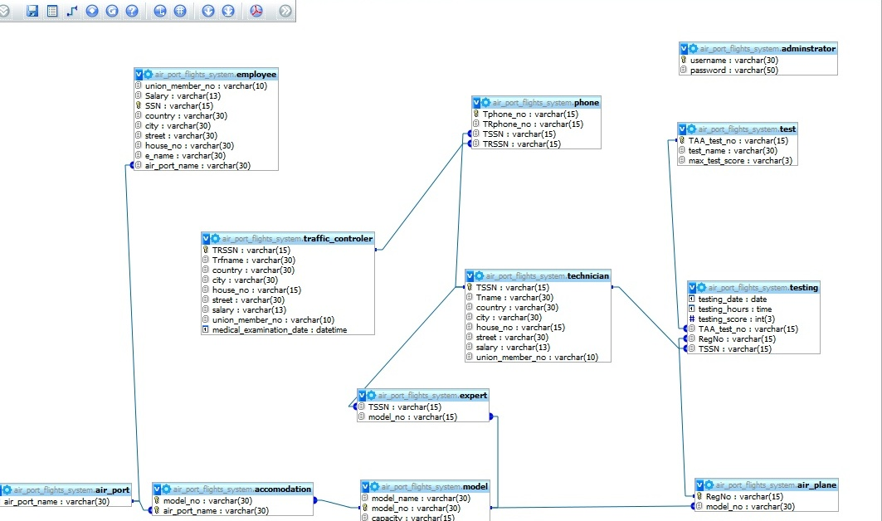

# REALATIONAL SCHEMA

Accommodation (model_no,air_port_name)

Air_plane(RegNo, model_no)

Air_port(air_port_name)

Employee(SSN, salary, country, city, street, house_no,e_name, air_port_name,union_member_no)

Expert ( TSSN, model_no)

Model ( model_no,model_name,capacity, weight)

Phone(Tphone_no,TRphone_no,TSSN, TRSSN)

Technician (TSSN,Tname,country,city,house_no,street,salary,union_member_no)

Test (TAA_test_no,test_name, max_test_score)

Testing (testing_date, testing_hours,testing_score,TAA_test_no,RegNo,TSSn)

Traffic_controller( TRSSN, Trfname, country, city,house_no, street, salary, union_member_no, medical_examination_date)

Administrator(username, password)

# Each Table, Attributes and Data type

Table Name: Air_plane

|  |  |  |  |
| --- | --- | --- | --- |
| ATTRIBUTE | DATA TYPE | LENGTH | KEY |
| RegNo | Varchar | 15 | Primary key |
| model_no | Varchar | 30 |  |

Table Name: Air_port

|  |  |  |  |
| --- | --- | --- | --- |
| ATTTRIBUTE | DATA TYPE | LENGTH | KEY |
| air_port_name | Varchar | 30 | Primary key |
|  |  |  |  |

Table Name: Employee

|  |  |  |  |
| --- | --- | --- | --- |
| ATTRIBUTE | DATA TYPE | LENGTH | KEY |
| SSN | Varchar | 15 | Primary key |
| Salary | Varchar | 13 |  |
| union_member_no | Varchar | 10 |  |
| Country | Varchar | 30 |  |
| City | Varchar | 30 |  |
| Street | Varchar | 30 |  |
| house_no | Varchar | 30 |  |
| e_name | Varchar | 30 |  |
| air_port_name | Varchar | 30 |  |

Table Name: Model

|  |  |  |  |
| --- | --- | --- | --- |
| ATTRIBUTE | DATA TYPE | LENGTH | KEY |
| model_no | Varchar | 30 | Primary key |
| model_name | Varchar | 30 |  |
| Capacity | Varchar | 15 |  |
| Weight | Varchar | 15 |  |

Table Name: Test

|  |  |  |  |
| --- | --- | --- | --- |
| ATTRIBUTE | DATA TYPE | LENGTH | KEY |
| TAA_test_no | Varchar | 15 | Primary key |
| Test_name | Varchar | 30 |  |
| max_test_score | Varchar | 4 |  |

Table Name: Technician

|  |  |  |  |
| --- | --- | --- | --- |
| ATTRIBUTE | DATA TYPE | LENGTH | KEY |
| TSSN | Varchar | 15 | Primary key |
| Tname | Varchar | 30 |  |
| Country | Varchar | 30 |  |
| City | Varchar | 30 |  |
| house_no | Varchar | 15 |  |
| Street | Varchar | 30 |  |
| Salary | Varchar | 13 |  |
| union_member_no | Varchar | 10 |  |

Table Name: Traffic_controller

|  |  |  |  |
| --- | --- | --- | --- |
| ATTRIBUTE | DATA TYPE | LENGTH | KEY |
| TRSSN | Varchar | 15 |  |
| Trfname | Varchar | 30 |  |
| Country | Varchar | 30 |  |
| City | Varchar | 30 |  |
| house_no | Varchar | 15 |  |
| Street | Varchar | 30 |  |
| Salary | Varchar | 30 |  |
| union_member_no | Varchar | 10 |  |
| Medical_examination_date | date |  |  |

# 

# SQL Queries:

Select *from AIRPLANE;

Select *from AIRPORT;

Select *from EMPLOYEE;

Select *from MODEL;

Select *from TEST;

Select *from TECHNICIAN;

Select *from TRAFFIC CONTROLLER;

1. Show the result after searching an Airplane Model.

Ans: select * from model where model_no= “& "'" &LTrim(keyword)

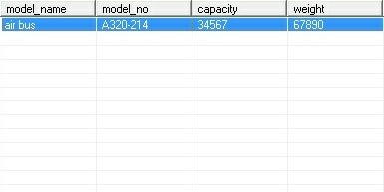

2. View theAirplane.

Ans: select m.model_name,m.model_no,a.RegNo,m.capacity,m.weight from model m,air_plane a where m.model_no=a.model_no

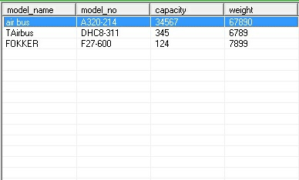

3. Test of all Airplanes.

Ans: select * from test

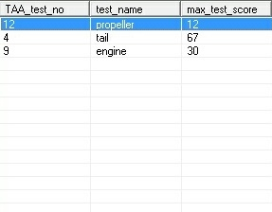

4. Find the numbers of Airplane available.

Ans: select count(RegNo) from air_plane

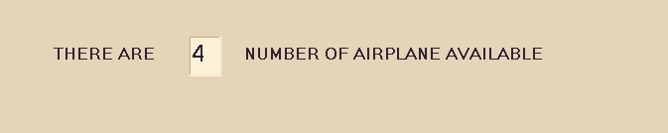

5. List all of the Airplane.

Ans: select RegNo,model_no from air_plane.

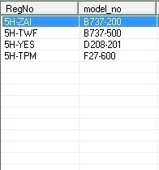

6. List all of the Technician.

Ans: select * from technician

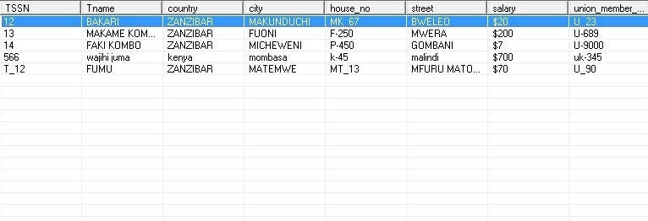

7. List the Traffic controller .

Ans: select * from traffic_controler

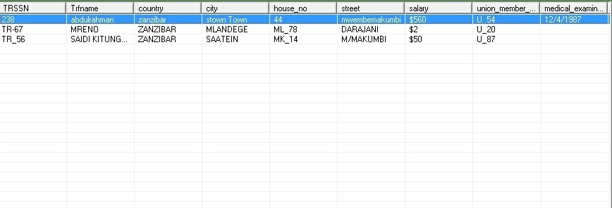

8. Find the number of test performed in a particular year.

Ans: : select distinct t.testing_date,t.testing_hours,t.testing_score,s.TAA_test_no,s.test_name from testing t, test s where testing_date between ('2010/01/01') and ('2010/12/31')

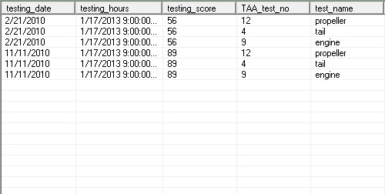

9. Find the list of Test performed.

Ans: select * from test

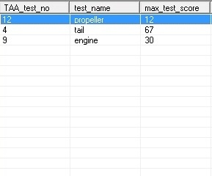

10. Find the plane that are not decide to land.

Ans:selectm.model_name,m.model_no,m.capacity,m.weight from model m where m.weight>5000

# D:\6th Semester\screenshot\screen2\DB10.JPG

## VIEW:

***Simple View:***

11.Create a view model01 that contains details of model with Capacity 100.

Ans: create or replace view model01 as select model_no, model_no, model_weight from model where model_capacity= 100;

12. Create a View Emp02 that contains only 4 employees.

Ans: create or replace view Emp02 as select *from employee where Emp02='4';

***Complex View:***

13.Create a view Emp03 that contains employee minimum, maximum & average salary according to salary.

Ans: create or replace view emp03(name, minsal, maxsal, avgsal) as select e.e_name, min(e_salary),max(e_salary),avg(e_salary) from employee e group by e.e_salary;

**SEQUENCE:**

14. CREATE SEQUENCE MODEL_NO INCREMENT BY 1 START WITH 91 MAXVALUE 100 NOCACHE NOCYCLE;

# 15. CREATE SEQUENCE union_member_no INCREMENT BY 1 START WITH 91 MAXVALUE 100 NOCACHE NOCYCLE;

**Our Experience from This Project**

We have done the project together. We have used internet & collected some information. After collecting information, we were ready to do this project. At first we draw the ER diagram of our design. Then translating ER model into the logical design showing the relational schemas and integrities then developing the database using MySQL together with oracle, then developing the front end application to perform the required operations. Thus due to the design and development of airport’s database as a database administrator we were able to organize all the information necessary about the airplanes stationed and maintained at the airport.The complete and proper implementation of all the required detail will lead to the effective management and control of the most airport facing problems on airplane management. We hope this experience of doing this project will help us in future.